Parts of Robot: Robot Dance: Learning to Program a Sequence

Subject:  Related Subjects: | Grade Level(s):  Length of Lesson: 65-75 Minutes | Type: Inquiry / Design / Project  Keywords: sequence, algorithm, program/programmer, code/coding/coder, input, output

Lesson Overview
Use this section to describe at a high level what the lesson is. Should be no more than 3-4 lines.

Lesson Focus
Students will design, test and revise a sequence (algorithm) of steps for a partner (robot) to follow. At the end of the lesson, students will construct an explanation responding to the question, “How do robots know what to do?”

Lesson Objective(s) | Students will simulate a programmer-robot interaction to create, test, and  revise a sequence (algorithm) of movements (i.e., a dance) to be executed  by a partner (robot) that explains how humans communicate with robots  through programs which tell the robot how to respond to input and act on  the physical world.  Telling Objective: (What teacher will announce to students)  “Today, in pairs, you will take turns pretending to be either a robot or a computer programmer.Student robots will act out commands, and student programmers will code the commands. A programmer is a person who writes commands for a computer in a language a robot can  understand.”

Lesson Timing

7 minutes | Anticipatory Set/Motivation/Hook:
5 minutes | Link to Existing Background Knowledge:
15 minutes | Demonstration
5 minutes | Check for Understanding
10 minutes | Guided Practice
15 minutes | Independent Practice
10 minutyes | Closure/Evaluation

Materials | Mentor and Teacher will have:  - Fully charged Dash Robot and tablet – one per mentor  - White board/chart paper and markers  - Handout of C.O.D.E.R. characteristics  - Extra handout for each student to code a rectangle and record the Twist code during activity  - Assessment #2 to hand out  Each Student will have:  Their notebook and pencil  ADVANCE PREPARATION:  Each mentor will have one Dash and pre-program Lesson 2 dance (NOTE: all mentors will program the same dance below, which is the beginnings of the ripple we will work on in future lessons). Mentors can pre-program Dash before the lesson or while students complete the assessment.  Sequence: All robots will move forward 30cm at normal speed, spin in a complete circle to the right, move backward 30cm at normal speed, and spin in complete circle to the left. Repeat once (robot performs this sequence twice.)  Mentors will pre-assign pairs of students to start as either  1) programmer or  2) robot,  Then switch roles half way through the lesson.  Mentors obtain their students’ notebooks prior to the start of the lesson.  Assessment #2:  Each mentor will hand out copies Assessment #2 for students to complete. LEAD MENTOR will collect and return Assessment #2 to the VAST OFFICE -- DRB #254.
Instructor Prep | - Step 1
Related Resources | - Mentors unfamiliar with the 1960’s dance called the Twist should Google it or check out this  Website: http://sixtiescity.net/Culture/dance.htm

Lesson Plan

Introduction

During the assessment, mentors take roll for their groups. Tell teacher of any absences.

a) Start in small groups. Mentors will inform students that the session today begins by seeing how much they remember from last week by completing the worksheet - this is NOT a test.

b) Distribute Week 2’s Assessment.

c) Mentors will provide students no more than five minutes to complete the assessment. Keep everyone to the five-minute limit so the time is the same for everyone -- it’s ok if students cannot finish, as time is part of the assessment.

d) Mentors collect assessments, checking to see that student names, school, and date are on each sheet. Lead mentor gathers all the assessments to deliver to VAST.

1. Anticipatory Set/Motivation/Hook: ~ 7 minutes

The anticipatory set should hook the students by engaging them in an interesting, thought-provoking task. An exciting anticipatory set motivates students to want to learn more.

a) Mentors continue in their pods. Have Dash perform the pre-programmed dance steps (see above).

b) Mentor will say: “Please describe each step to the Dash dance you just watched.” (Mentor can demo the dance sequence again as many times as necessary.)

c) Mentor randomly records the student responses to the whiteboard. Then ask the group to reorder the responses in the sequence of the dance.

2. Link to Existing Background Knowledge: ~ 5 minutes

This portion of the lesson helps students to access the knowledge they already have and introduces them to what they are about to learn.

a) Mentors ask students how robots know what to do and review the robot parts learned during last week’s lesson (and included in Assessment #2), linking parts to their functions:

a) Mentors will ask students what the controller is like (the robot’s brain) and also what the actuator does (moves the robot).

b) Mentor hands out the students’ notebooks and tells students to look at the top of Lesson #2:

“The robot parts enable the robot to perform its output, and the program is part of the robot’s input. Remember that a robot is programmed, which means that a programmer writes commands or instructions that the robot follows. This sequence of instructions is called an algorithm.”

c) Explain that people have sequences of activity in their daily lives, so students can start paying attention to the sequences or algorithms in their lives. For instance, there is an algorithm for taking a bite of cereal, brushing your teeth, or solving a math problem. Recipes are also algorithms, because to prepare food, you must follow the same steps in the same order each time. Ask for a few more examples.

d) Mentor will ask students: “Who remembers the C.O.D.E.R. characteristics?” and prompt students to give examples of how they can practice this type of behavior as they act as the “programmer” and “robot” (C.O.D.E.R. = collaborative, open-minded, determined, enthusiastic, respectful). Mentors emphasize that these values will be important to demonstrate today as they learn to program.

Procedure

3. Demonstration: ~ 15 minutes

In this section of the lesson, the mentor/teacher will provide the students with the new information they need to know to meet the objective for the lesson.

a) Tell students they are going to learn about sequences by pretending to be a robot so they can see that a robot needs very specific instructions.

a. Next, look at the bottom of the Lesson 2 handout in their notebooks to see a screenshot of Blockly code. Mentor should read it out loud and explain to the students that 50 (in the Forward 50 command) is a measure of distance. The turn command has a 90 next to it; that informs the robot to turn on a 90 degree angle. Ask the students: “Who can show me what a 90 degree angle is?”

b. Now that they understand the numbers, have students perform the sequence. Students should substitute 3 steps for the 50 in the Blockly screenshot. This sequence makes a square. Mentors clarify any confusion about the input (code on the handout) and the output (the square that students will make by acting out the sequence on the notebook handout.)

c. Pass out the extra handout for Lesson 2 and ask students to work on the first page, filling in the blanks to write a code telling Dash to move fast in the shape of a rectangle, turning right. Remind them a rectangle has a longer top and bottom than its sides. Help students fill in the blanks.

b) Mentor tells students they will work in pairs as a pretend “programmer” and a pretend “robot” in order to learn to write an algorithm. This algorithm will be used to code the steps a human would follow to dance the Twist.

c) The mentor will model thinking out loud about how one would write a dance move in the

Twist:

“Who knows the dance, the Twist? How do you do it? (Have students model or mentor can physically model the dance.) If someone had never heard or seen this dance, how would you tell them what to do with their body?”

d) Have students narrate the sequence of steps to a simple dance move while the mentor writes the ideas down on the white board or paper.

e) Next, the mentor reminds students that the written instructions are the robot’s input and now we will focus on the output. Call on one student at a time to act out a few of the steps exactly as written, being sure not to fill in any gaps in the dance instructions or add anything that is missing. Students will notice that they may need to add details to clarify the sequence about how to move the arms, hips or anything they may have missed.

f) Students and mentor will add the steps necessary to create an “algorithm” for the Twist that can repeated so that everyone can clearly see the “code” for telling someone how to do a dance step to the Twist.

4. Check for Understanding: ~ 5 minutes

Generally, before guided practice, the mentor/teacher will want to do a class-wide check to make sure the students understand the information that they have just been provided. The mentors ask students to narrate the instructions for doing two new simple dance steps. By raising their hands, students will take turns inventing and narrating simple steps, e.g., turn head left then right. Working together, the mentor narrates instructions for the two dance steps while students record those in their new handout before they move on to working in pairs.

5. Guided Practice: ~ 10 minutes

Here, the mentor/teacher and student practice the application of the new material together. The

teacher may model the activity as the students follow along.

a) The mentor places students into pre-assigned pairs (also called dyads) and designates one

person in each pair as the “robot” and the other as the “programmer,” reminding students

they will switch roles midway in the activity. Students will have two minutes to quickly

collaborate on naming one short dance step within the Twist (e.g., twist arms to the left, twist

arms to the right);

b) The students will quickly go around their group, with each pair demonstrating while narrating

their selected dance step (emphasize that input is as important as the output, so the pair

must narrate the step, not just perform it). This should be quick and fun, but the mentor ask

questions to clarify any vagueness in the narration or to correct misunderstandings about

input, output, or sequence.

c) The mentor emphasizes that students will continue this work, writing down their steps they

practice before they actually begin to code their robot to dance next week.

6. Independent Practice: ~ 15 minutes
This part of the lesson allows the students to apply what they have learned on their own.
a) Students work in pairs collaboratively for five minutes, with the pretend “robot” suggesting two simple dance steps while the pretend “programmer” writes down the steps on today’s extra handout.
b) Coming back together as a pod, students will take turns to watch each pair as a “programmer” reads the code out loud while the “robot” acts out the code. After each dance, students discuss ways to write the instructions for those dance steps. (This is an important process of learning computational thinking by doing it.)
c) Going back to dyads, each student will switch roles (the robot becomes the programmer and vice versa), and repeat the entire process for one complete turn, such that each student in the dyad gets practice as both the programmer and the robot.
d) Coming back together as a pod, students will take turns to watch each pair as a “programmer” reads the code out loud while the “robot” acts out the code.
e) Tell everyone to put the extra handout in the pocket of their notebooks.

Wrap-up
7. Closure/Evaluation: ~ 10 minutes
This section of the lesson concludes the lesson for the students by requiring them to summarize or reflect on what they have learned.
a) Mentors wrap up the activity in their pods, closing with these questions:
a. What did you notice when you were writing an “algorithm” for your “robot?”
b. What did you notice when you were the “robot” and you were “running” an algorithm?
b) Have students answer the question, “How do robots know what to do? What is their input and output?”
c) Students complete CLOZE passage in their notebooks:
Correct answers: A programmer is a person who writes commands for a computer in a language it understands. When writing a program, one needs to break down the sequence into very specific steps. An algorithm is a sequence of instructions, or rules to follow, for performing a task. A robot uses the input from its sensors and a program to make decisions and act. A robot’s actions are its output.
d) Students write for three minutes under the CLOZE passage in their handout:
a. What are some examples of different algorithms that you use in your life?
e) Have student go back to the Line of Learning sheet (page 2 of their notebooks), “How do robots know what to do?” Students should read their previous responses and draw another “Line of learning” under their previous response and add the date to the line so they can see how their ideas evolve each week. Ask students to discuss what they would like to add to or change in their response. Have them write these ideas under today’s Line of Learning.
f) Have students put today’s handout into the front folder part of their notebook along with the
pencils. Close their notebooks and pass them up to the mentor.

9. After Class – Teacher and all the mentors

Mentors and teacher put away equipment and notebooks so everyone knows where these are stored. When will teacher be able to charge the tablets and Dash robots before the next class? Briefly review Assessment #2 with the teacher and all mentors after class to see how many students remembered the robot components – Lead mentor arranges to get these assessments to the VAST office (DRB #254). Do not lose the Assessment. Also let Lead Mentor and teacher know if any students were absent so we can track this.

Mentors and the teacher should always take 5 – 10 minutes after class to check in with each other about how the class went – what worked well, what needs improvement (let us know your ideas – we welcome your suggestions), which groups seem to be off to a good start, notice any behavioral challenges. Communicate your observations to us at vast@usc.edu -- THANKS!

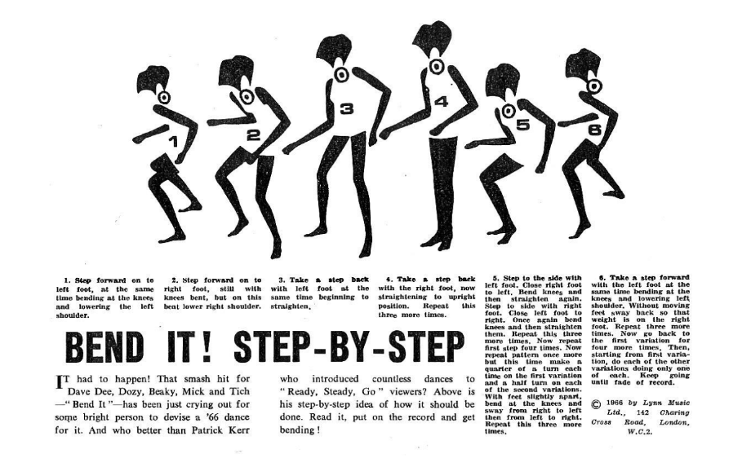

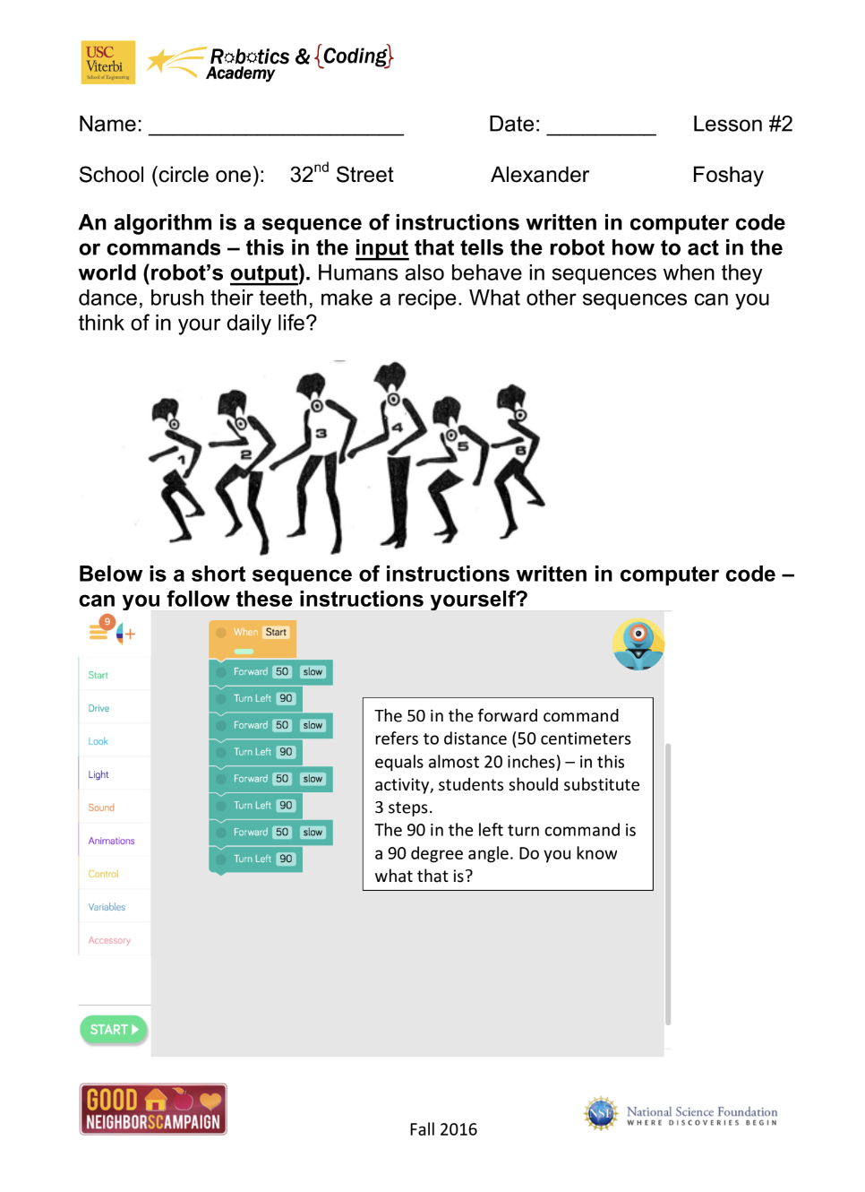
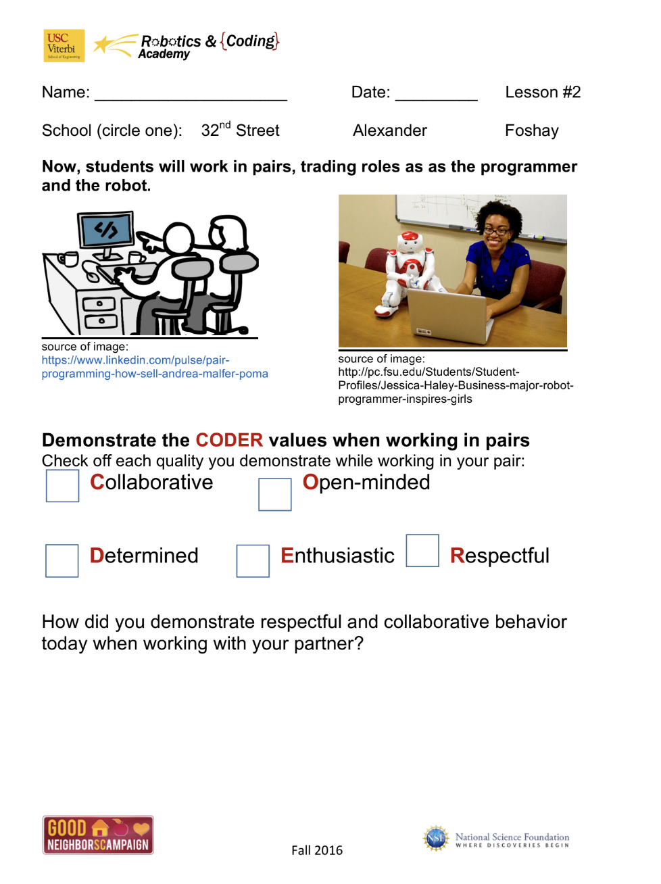
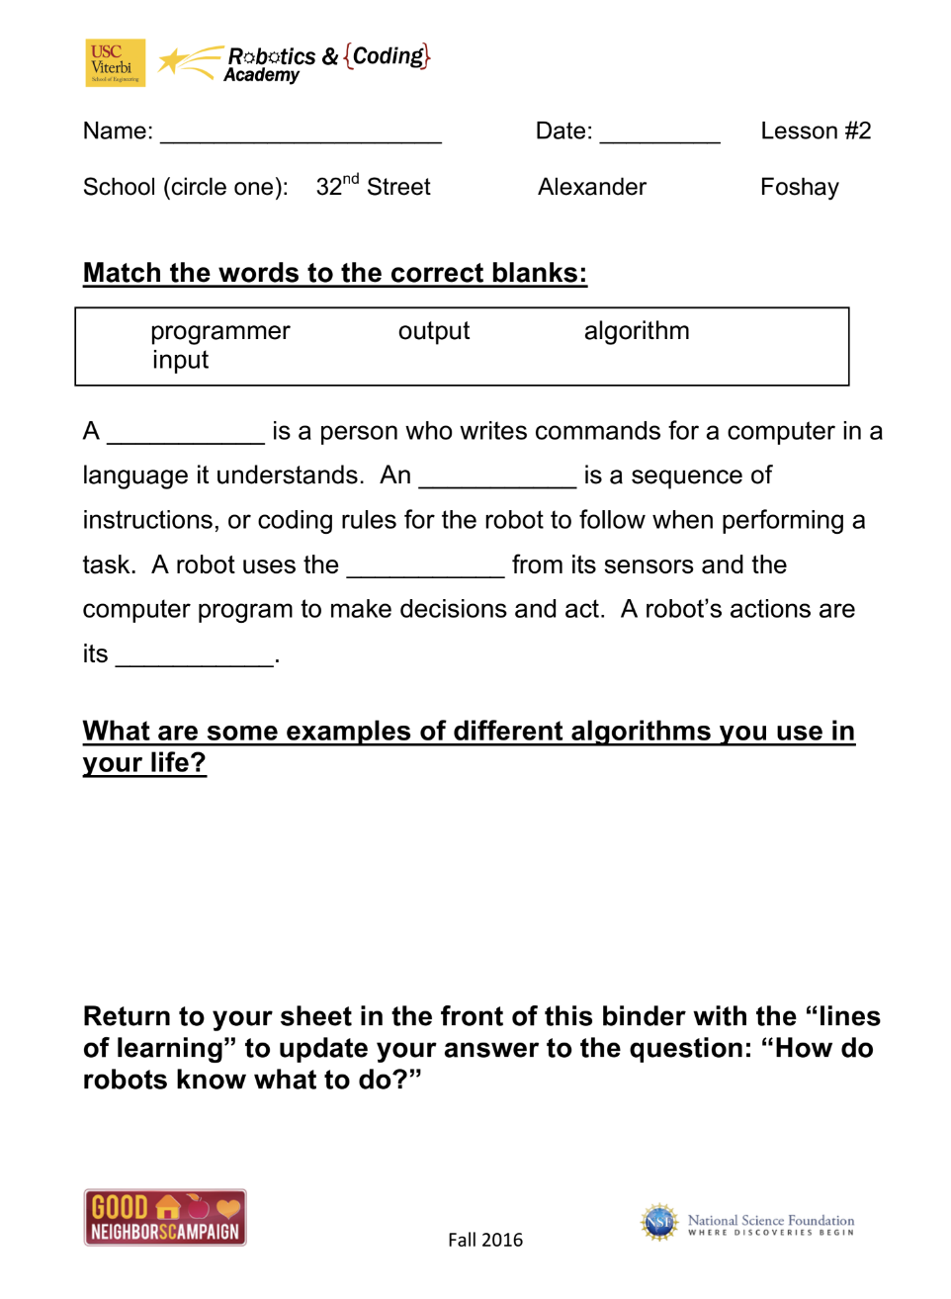

Lesson Background for Teachers

Suggested Real-World STEM Connections
- List possible related Role Models in STEM (with details and links to more reading). Give suggestions for examples of scientists/engineers who are from underrepresented groups in STEM in related careers.
- List related real-world engineering problems and examples

Lesson Variations and Options
Include descriptions of alternative methods or ways to present things.

Explanation
Describe the background concepts and explanations behind the lesson. This can be more in depth than a teacher/instructor would actually share with students.

Key Concepts and Vocabulary
- Word 1: Grade Appropriate Definition
- Word 2: Grade Appropriate Definition

Safety Notes
- Safety instruction

